

International Student Ministry Version - ***DRAFT***

**FOLLOWING JESUS PATHWAY**

The Following Jesus Pathway is a framework to develop and encourage as many friends as possible using discipleship cycles at each step. In partnership with the Holy Spirit, we help *everyone* in our chapter family grow and reach more of the campus and the world!

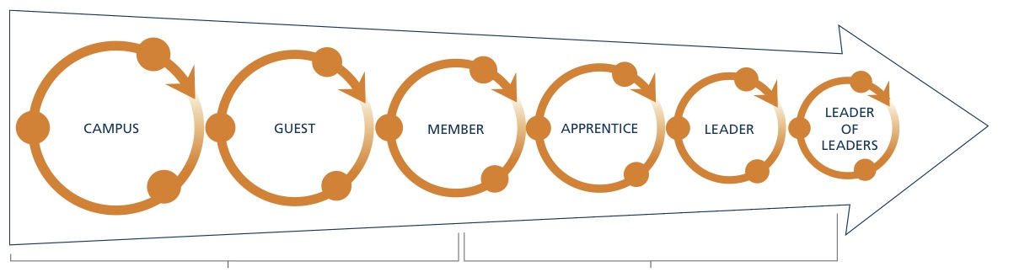

LITTLE BROTHER/ SISTER

BIG BROTHER/SISTER

UNCLE OR AUNT

OUT TO THE WORLD

NATIONS

NATIONS

Welcoming Everyone to Experience Jesus

Inviting Onto the Servant Pathway

CAMPUS GUESTS FAMILY MEMBERS LITTLE BROTHER/ BIG BROTHER/ UNCLE OR AUNT SISTER SISTER



**WHO**

Write down the names of the people in your chapter family and what column seems to best describe where they are on the Following Jesus Pathway.

NEXT STEP FOR WELCOMING EVERYONE

I will ask _____________________, and ________________ to _________________________________________with me

NEXT STEP FOR THE SERVANT PATHWAY

I will ask _____________________, and ________________ to _________________________________________with me

**WHAT**

Choose a few friends you know or want to know in each section of the Following Jesus Pathway and plan a next step to invite them further into the family.



FAMILY